Study Guide Project

**Wide Area Network-** A network used to connect computers over large geographical distances

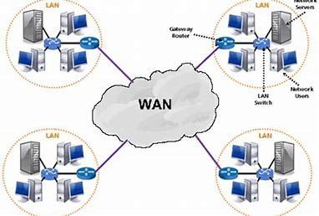

**Network Redundancy-** is a process through which additional or alternate instances of network devices, equipment and communication mediums are installed within network infrastructure.

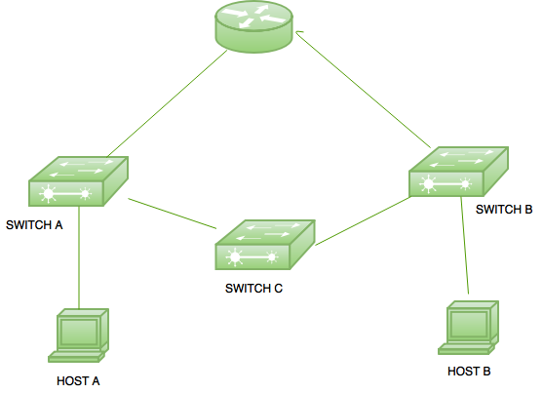

**Communication links-** is the means of connecting one location to another for the purpose of transmitting and receiving data.

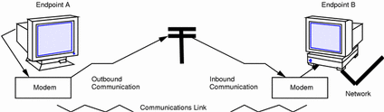

**Net Neutrality-** is a principle that asserts that governments and Internet service providers should not place restrictions on consumers' access to networks participating in the Internet.

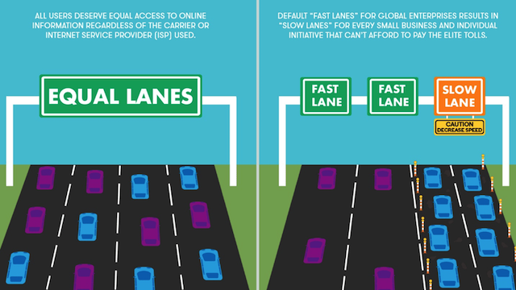

**Packet switches-** is a digital network transmission process in which data is broken into suitably-sized pieces or blocks for fast and efficient transfer via different network devices.

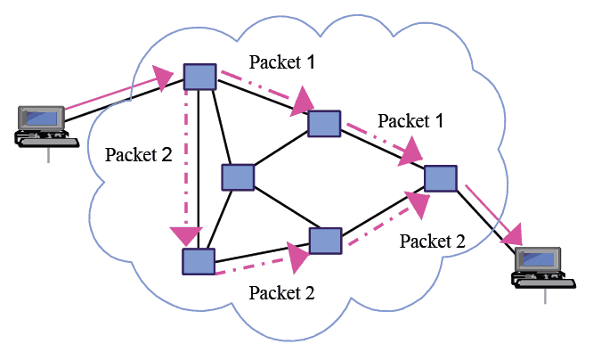

**Transmission rate-** refers to the rate at which data is processed or transferred.

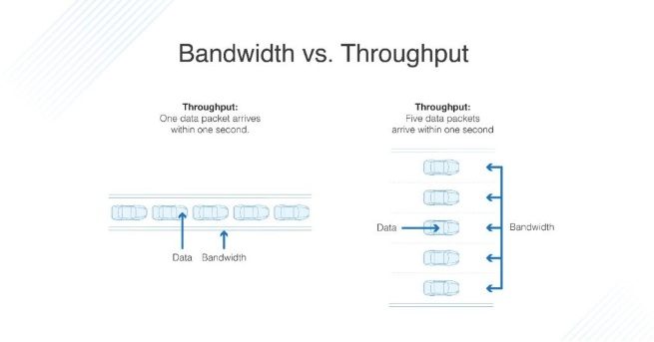

**Link-layer switches-** is the process of forwarding data frames or packets from one port to another leading to data transmission from source to destination.

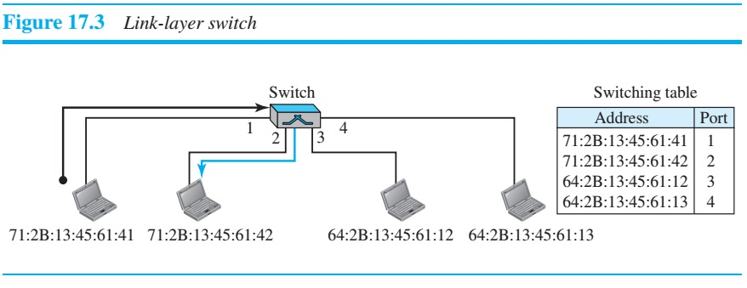

**Wireless network-** A type of network that does not require the use of cables.

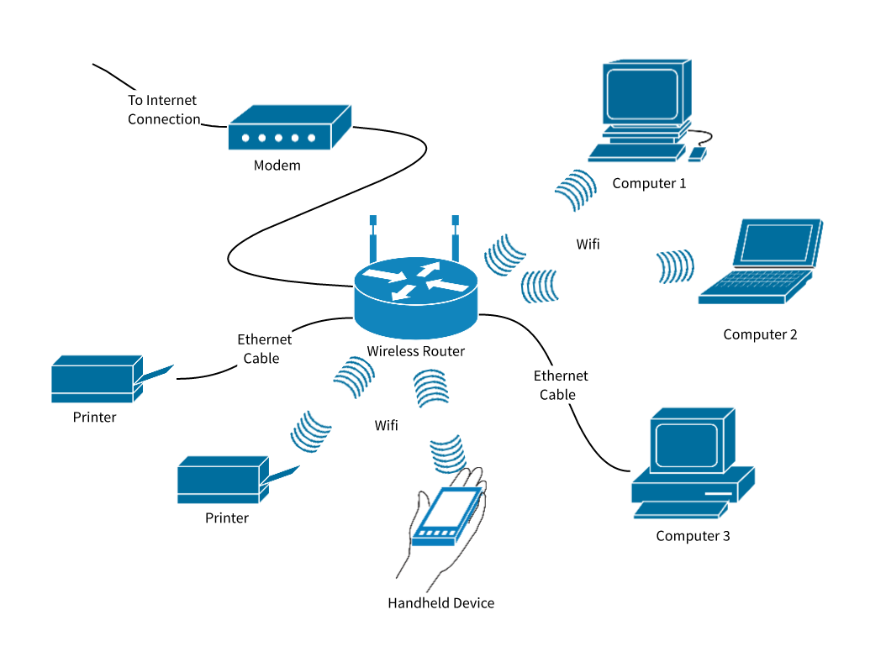

**Utility program-** Program run by the operating system to manage input and output, read and write to memory, manage the processor, maintain system security, and manage files and disks.

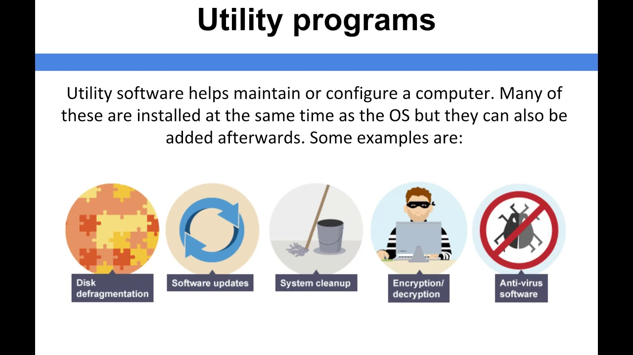

**Telecommunications-** The transmitting and receiving of data.

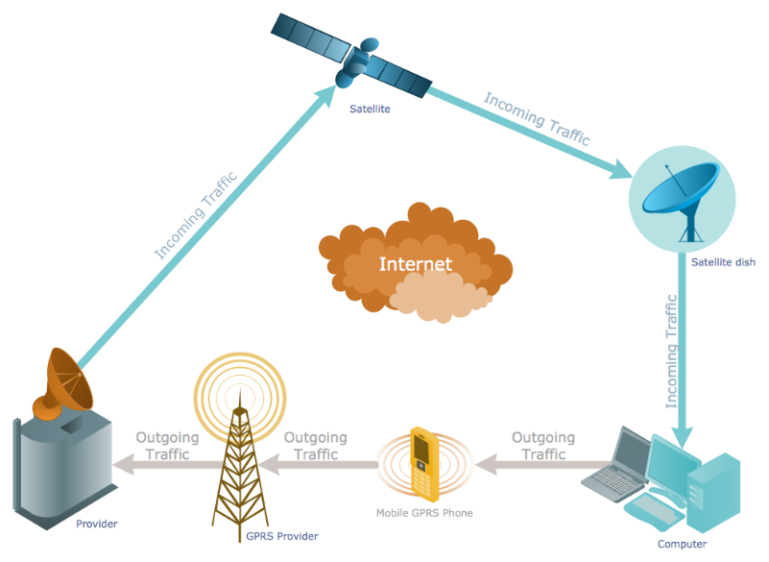

**Network architecture-** The structure of a network.

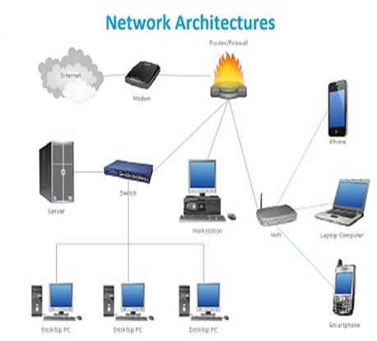

**Local Area Network-** A network used to connect devices within a small area.

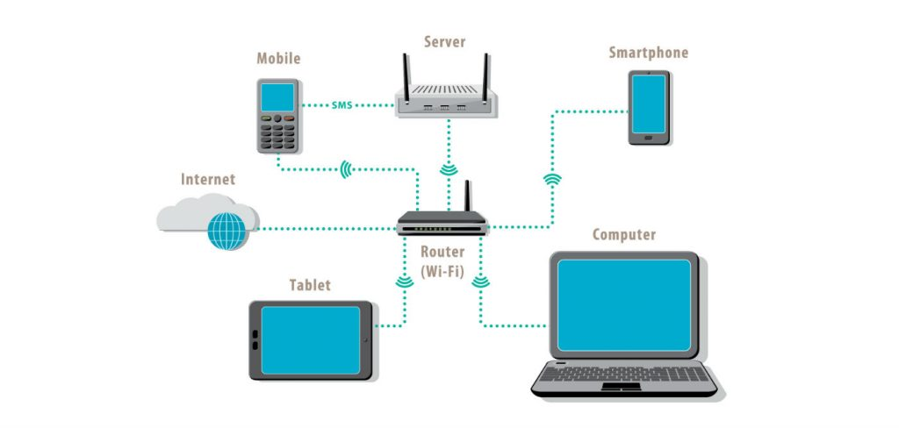

**Digital subscriber line access multiplexer-** is a networking device that connects multiple DSL subscribers to one Internet backbone.

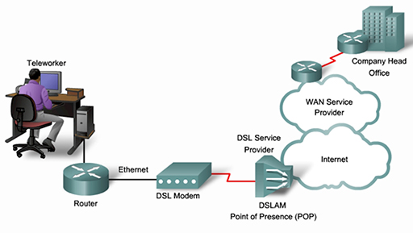

**Fiber to the home-** is a fiber optic communication delivery form where the fiber extends from a central office to the boundary of a home living space or business office.

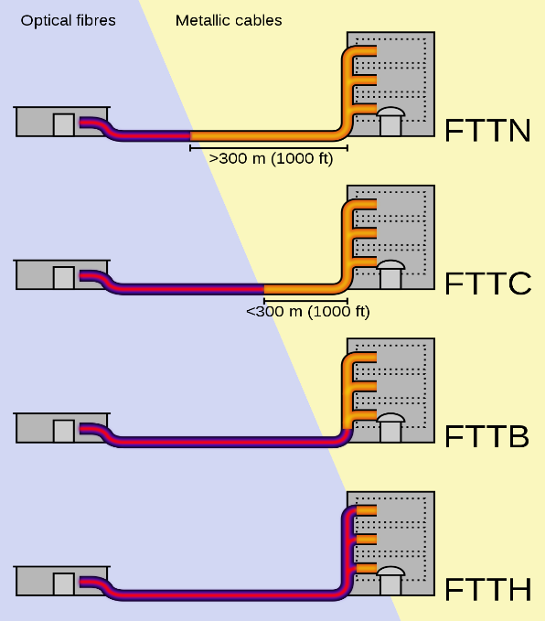

**Cable Internet access-** is a form of broadband Internet access which uses the same infrastructure as a cable television.

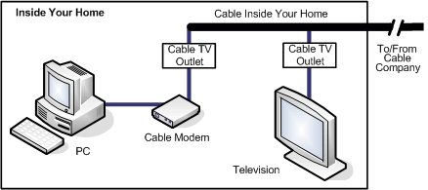

**Internet Protocol-** is the principal set (or communications protocol) of digital message formats and rules for exchanging messages between computers across a single network or a series of interconnected networks, using the Internet Protocol Suite (often referred to as TCP/IP).

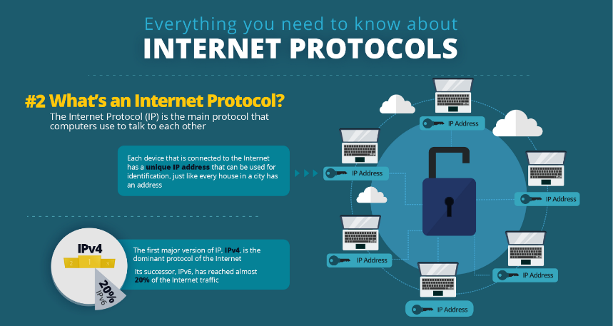

**Internet Standards-** is a specification that has been approved by the Internet Engineering Task Force (IETF).

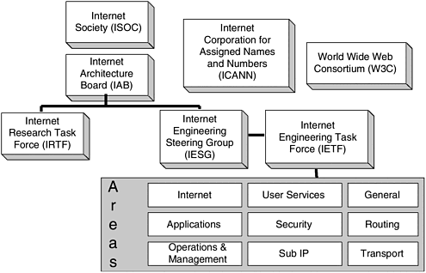

**Requests for comments-** is a formal document drafted by the Internet Engineering Task Force (IETF) that describes the specifications for a particular technology.

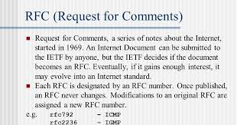

**Local Area Network-** A network used to connect devices within a small area.



**Services Descriptions-** descriptions of the functional and nonfunctional properties of the service, service interfaces, and the legal and technical constraints or rules for its usage.

